Western Port Catchment Landcare Network
Project Expression of Interest

Name:
Landcare Group (where applicable):
Postal address:
Town: Postcode:
Home ph.: Mobile:
Email Address:
GST registered? YES NO ABN:

Address of project site:

Size of your property:
Enterprise type:

Guidelines
- Grants are available for revegetation and remnant protection projects;
- All projects must be a minimum of 10 m wide;
- All species planted must be indigenous to the area;
- Stock must be permanently excluded from the project area;
- All projects must be on private land only.

Incentive | Cost per unit* | Estimated Quantity | Estimated Cost*
Fencing Subsidy- Revegetation |  | metres
Indigenous species  (2200 plants/ha) |  | tubestock
Weed management
Tree Guard Sets
Seed (2kg/ha) |  | kg
Total cost
* Project costings will be finalised after site visit from project officer and the development of management plan/contract.
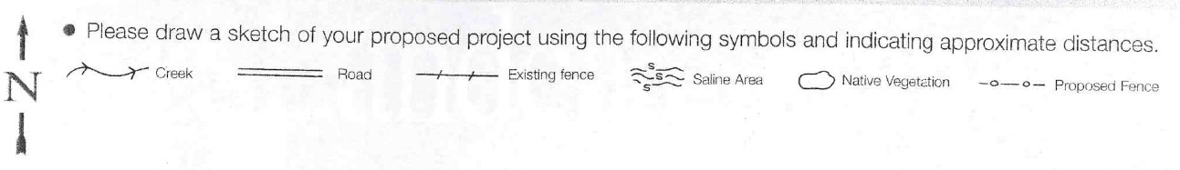

Yes, I am interested in undertaking land management works on my property and I am committed to managing the area that is the subject of this application while I am in the ownership of the site. This means I will maintain the fences established as part of this project and ensure all processes that could negatively impact on the outcomes of this project (such as weed invasions, damage by pest animals, trafficking or grazing) are prevented.

Signature: Date:

I give permission for my name & property to be included in future grant applications for project funding.

Signature: Date:

Kathleen Roberts 0488 013 613 kathleen@wpcln.org.au

Office 03 5941 8446 PO Box 875, Pakenham 3810

